**Performance Test Report**

**For**

**Execution of**

**Masterdata applicanttype – 250 users**

Date: 05 June 2020

Author: Gaurav Sharan

**Summary**

This report presents the observations and findings of the load test conducted for a load of 250 users on masterdata applicanttype API.

The objective of this load test was to observe and record behavior of the application when user load is increased from 50 to 250.

Below are the scenario details:

|  |  |
| --- | --- |
| **Script/Report Name** | Masterdata applicanttype API |
| **Run Date** | 05-June-2020 |
| **Period** | 04:37:34 UTC to 06:30:13 UTC |
| **Number of concurrent users** | 50 to 250 |
| **Ramp up** | 01 users per second |
| **Run Duration** | --- |
| **Ramp down** | NA |

The transaction response times observed were as below:

|  |  |  |  |  |  |  |  |
| --- | --- | --- | --- | --- | --- | --- | --- |
| **Label** | **# Samples** | **Average(ms)** | **90% Line(ms)** | **Min(ms)** | **Max(ms)** | **Error %** | **Throughput** |
| TR_masterdata_ applicanttype | 391333 | 1797 | 5037 | 8 | 60596 | 30% | 57.9 |

**Performance Test Execution Details**

We have executed JMeter script for masterdata applicanttype service, which has transactions mentioned in the above table.

Average response time of the APIs is 1797 ms with error rate ~30 %.

**Response Time and TPS Graph:**

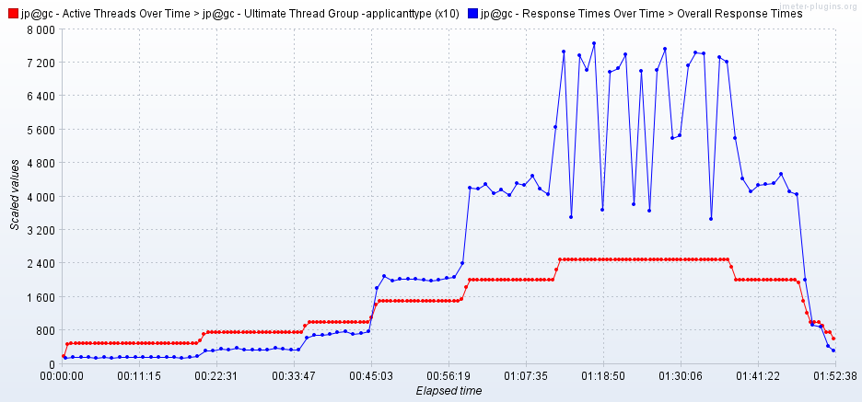

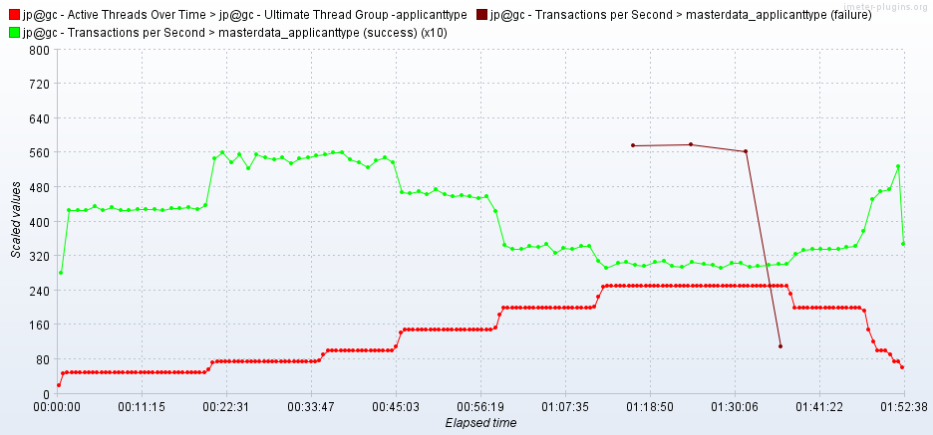

As seen in the graph, response time of the APIs is approx 01 second when 100 users are active, then response time increases with increase in number of users.

Response time crosses 4000 ms when 200 users are active.

Failures are observed when 250 users are active.

Throughput (TPS) of the APIs approxes 56 when 100 users are active and reduces with increase in number of users.